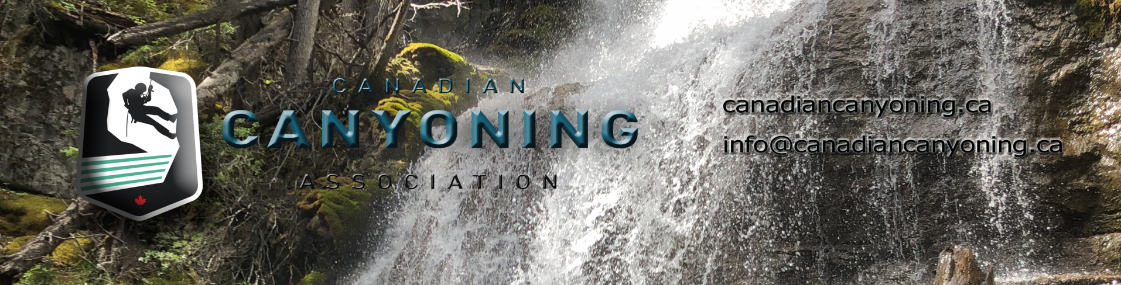

Canadian Canyoning Association Objectives and Mission

Name:
1 The name of the Association is Canadian Canyoning Association.

Mission Statement:
2 The Mission Statement of the Canadian Canyoning Association is:
Canadian Canyoning Association missoin is to foster the development and growth of the outdoor adventure sport of Canyoning (Canyoneering) within Canada through the establishment of best practices.

Objectives:
3 The objectives of the Canadian Canyoning Association are:
(a) To protect the public interest by advocating best practices and promoting high
standards of risk management for canyon guiding and its related activities.
(b) To represent its members in dealing with official bodies, both public and private.
(c) To establish and maintain professional standards of competence and conduct for
canyon guiding, instruction and rescue response and its related activities within Canada.
(d) To ensure that any organization that administers its training and certification
programs meet the standards established by the Association.
(e) To provide services to its members that enhance their ability to work in the
profession of canyon guiding and its related activities.
(f) To promote awareness within the general public of the Association and the
benefits of professional training and its related activities.
(g) To strengthen cooperation and promote cordial relations among its members.
(h) To promote and educate best practices to the public and recreational community.

